DETERMINING PROPORTIONATE SHARE

1. Go to the MDE website <https://education.mn.gov> and click on **Data Center / Data Reports & Analytics**

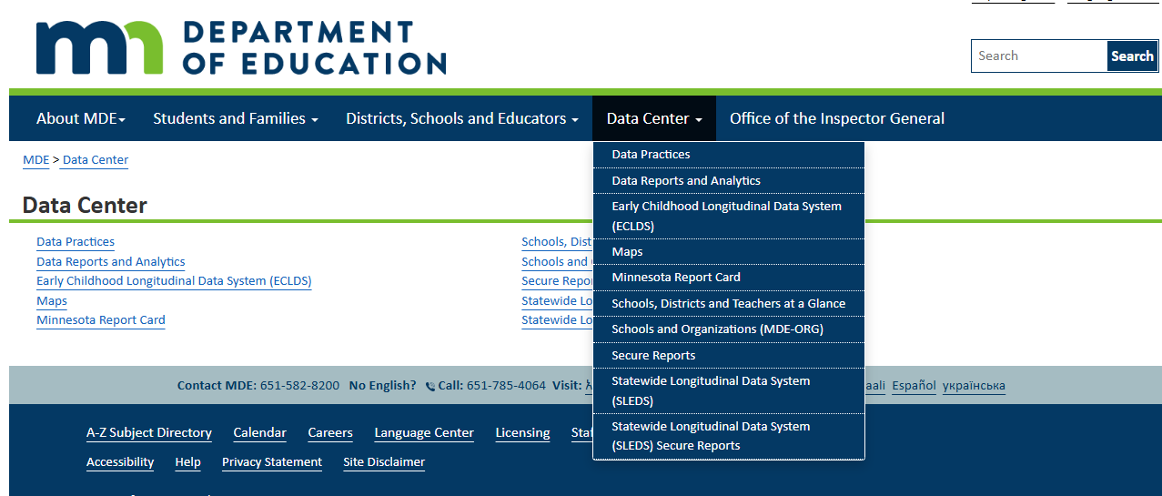

1. Scroll down to **School Finance Reports** and select **Minnesota Funding Reports (MFR)**

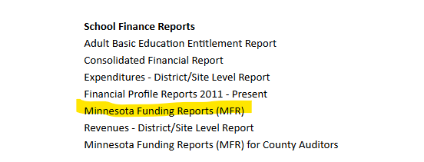

1. Click **Statewide (9999-99**) from the **District** dropdown menu
2. Choose **Special Education** in the **Category** dropdown menu
3. Click the appropriate year in the **Year** dropdown menu
4. Click “**Special Education Proportionate Share for Parentally Placed Students in Private Schools**” from the **Report** dropdown menu.
5. Then click the “**List Reports**” button to get the link to appear.

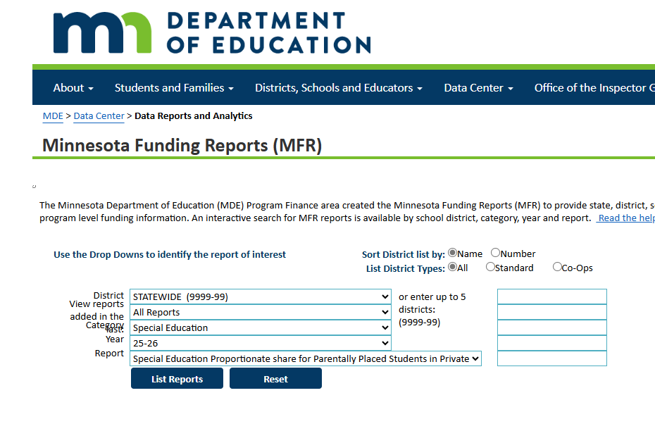

1. Open the linked document.

